- An overview of your salon website, its functionality and the role it plays within your business and marketing strategies.

Voodou is a small chain of 4 salon & barber shops in Liverpool plus a barber’s concession in Topman. We have been trading as a salon in Liverpool for over 30 years.

We have had a salon website for over 10 years, but our real focus on the internet began 4 years ago when we started working with Salon Guru, the online salon marketing experts.

They encouraged us to think of the internet as the biggest marketing opportunity for Voodou, appealing to our salon’s demographic of city centre dwellers, aged 20-35, students and young professional men and women.

Over the past 4 years we have had 3 generations of website – each one building on our experience and knowledge gained from the previous version. The latest incarnation of the Voodou website was launched in April 2012.

Our primary aims have always been to –
- create a very busy website with high traffic volumes
- totally integrate the website with our salon’s social networks
- offer lots of website engagement i.e. things to “do” and calls to action

We are confident that we can demonstrate an unbeatable record on all 3 points with -
- one of the busiest salon websites in the world (relative to number of salons)
- one of the biggest and most involved salon social networks in the world
- incredible income generation through online “engagement”

We have provided a detailed breakdown of our website traffic later, but we are proud of our year-on-year massive growth in website visitors.

In Quarter 1 of 2012 we attracted 63,000 unique visitors, an increase of 76% on the same period last year.

The Voodou website is an important part of our online marketing, but it is only part of strategy. Voodou also has probably the busiest Salon facebook page in the UK and one of the best in the world.

Our facebook fans passed 10,000 in October 2011 and by May 2012 had risen to 14,000

Aim 1 - create a very busy website with high traffic volumes
We believe our website to be busier than possibly any other salon in the UK, when related to the number of salons.

The graph below shows that we learn from experience and strive to add new features and ways to attract visitors with every new version of our website.

We measure success as unique visitors (people) rather than the more misleading “hits” which records the inflated value of every image, page and file opened by the browser.

Aim 2 - totally integrate the website with our salon’s social networks

Voodou has probably one of the biggest salon social networks in the UK (and world) with over 14,000 facebook fans and over 1,200 Twitter followers.

But we have learned over the past few years that integrating the conversations on facebook and Twitter with your website is vital if you want to engage with clients every day and in every way.

So not only do we feed facebook posts and tweets to our website, we also post lots of new stories, videos and images to our website which are then fed to our clients as links from our facebook wall and Twitter stream.

This means, when we have a story to tell, offer to promote or new service/product to sell –
we create the “story” on the website and can then reach a massive audience very quickly and easily with snippets and back-links on all our social networks.

We also use facebook connect on our website, so that anyone leaving a comment or question on the site uses their facebook login info and this then appears in their newsfeed and can be seen by all their friends.

The ability to create viral conversations that are seen by our fans, their friends and friends of friends is the true power of our social network.

Aim 3 - lots of website engagement i.e. things to “do” and calls to action
Having a very busy website is great, and supporting that with very engaged and popular social networks takes the online conversation with clients to another level – but the big effect on salon income only comes when you can “grab” those thousands of web visitors, fans and followers.

We constantly look for new and exciting ways to engage these “website browsers” and use many tools and tricks to ensure they become new salon clients and join our online family.

Engagement through content
We add new stories, galleries, images, product promotions and offers to our website every week. Whereas others may have a “blog” where they occasionally add new content, our entire website is a Content Management System (Wordpress).

This means we can change anything or add anything in minutes. Whether its Home page banners, promotional adverts and videos or news stories – we have complete control over the sites content on every page. This makes the Voodou website like a vibrant and interesting salon magazine

Engagement through offers/vouchers
We always have offers on our website and they change every week. They can be as broad as a new client voucher or as targeted as a short-term promotion on a product.

Offers are always supported by name & email capture –so the client registers for the offer by leaving their contact info and gets an automated email response as their “voucher”. This means we can accurately track take-up, send them an instant email and store their info for future marketing. We now have over 35,000 names & emails we use for regular email blasts and Newsletters.

Engagement through tools
New content is great for telling a story, and vouchers & offers capture the impulse buyer – but we also use other tools to capture website visitors to ensure their visit to our website is not a one-off.

Last Minute Voodou is shown in detail later – but it allows us to create our own late deals on the website. We can create a range of deals to fill empty appointment slots in the next few days and the system is 100% automated.

In the 1st month after launch (April 2012) we took almost £3,000 of Last Minute bookings, and unlike schemes like Groupon we do not have a painfully high minimum discount level or share the income.

Automated Client Surveys ensures every new client gets an email invitation to “take the survey” the week after their visit. The survey has automatic logic, triggers and actions so we can ask questions based on earlier answers and take actions based on answers – e.g. happy clients are –

- asked for feedback – from which we create Google reviews
- sent a thank you gift via email – as an incentive for their 2nd visit
- asked to Recommend a Friend who get an immediate email and introductory gift

Our new mobile phone app allows users to book-online, claim “late deals”, visit our website, check-in via facebook, watch videos, receive notifications when they are within 2 miles of the salon and a
great deal more.

“The Voodou website is incredibly busy, captures browsers as new clients and generates a great deal of new salon income.”

- Three examples of how your salon or salon group uses new technology within the business, e.g. social media, e-marketing, SMS marketing.

- Facebook
We created our facebook page in May 2009 and since then have worked very hard to build fans and also engage them with daily posts and good content. We already have possibly the biggest salon facebook page in the UK with over 14,000 fans and expect to reach 20,000 in the next few months.
Facebook gives us the ability to talk to our thousands of fans every day – and often several times a day. This means our News travels very fast and very wide, and any offers reach a massive potential audience instantly.

But lots of fans is not in itself a generator of income – we carefully monitor all the key statistics to ensure we know when to post, what to post and the kind of content that gets the most engagement.
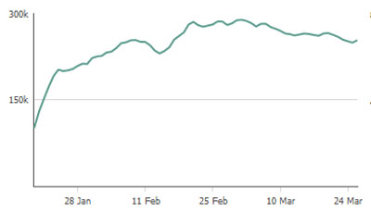

This graph shows that our facebook content was seen by up to 300,000 people a day in our city during Quarter 1 of 2012.

We also regularly promote our page and website with facebook adverts that can target viewers by gender, age, distance from the salon and even their interests.
We also promote our salon and services to friends of existing fans through sponsored stories. This kind of “recommendation by association” is the same as hand written Recommend a Friend cards – but the power of facebook’s interconnections means we can personalise every advert or story with the names and face of their friends that already “like” the Voodou page.
The Voodou facebook page is a powerful marketing tool, not just because of the size of our fan-base, but also because it involves our clients in a daily conversation that sells services and products.
We have learnt that you only get out of facebook what you put in
so we invest enormous energy and effort to maintain
one of the best Salon facebook pages in the world.

The Voodou facebook Timeline image
Links - Voodou website www.voodou.co.uk
faceboook page www.facebook.com/Voodou

- Email Marketing

Elsewhere we have explained that every offer, promotion and “deal” at Voodou requires the client to leave their name and email.

This has allowed us to build a database of over 35,000 contacts that we use for regular email blasts and newsletters.

Our enormous growth on Facebook has allowed us to have our daily conversations on our facebook wall and use email blasts and newsletters more sparingly for news stories, promotions and events that need more detail and information than short and punchy facebook posts are suited to.

We create multiple tables within our client database so that we can target emails based on interests and customer type - e.g. Hair Extensions, Hair Colour, Student.

For example we have stored –
2,800 contacts who have downloaded our guide to Hair Extensions
1,900 contacts who have downloaded our guide to Hair Colour
8,500 students
14,000 clients who have downloaded our new clients vouchers over the years

We also use automatic follow-up email reminders that are triggered some days or week after their initial sign-up.

Click-through rates for every link in our emails are monitored and we often run split-testing to see what messages, images and styling gains the most interest (clicks) before sending a very large email campaign.

Our most recent campaign focussed on the Last Minute Voodou system to help raise awareness and led to over 1,000 additional clicks through to our website in the first 4 hours.

Email marketing has always been an important part of our marketing strategy, but the increasing importance of Facebook has meant we have chosen to use this in a more targeted and planned way.

Emails lists that are defined by customer type and interests mean
we can now deliver more carefully crafted personalised messages with a greater chance of increasing salon income.

- automated online surveys
Every new client at Voodou now gets an invitation to “take our survey” via email on the Monday after their visit. We currently send about 100 per week which will increase when we introduce the system to 2 more of our salons.
The client survey is embedded within a page of our website and uses logic, triggers and actions to present a customised survey to every client and takes appropriate actions based on their answers.
The survey is constantly evolving as we learn the kind of questions and responses that give the best client feedback and also generate new income, but in its current form the survey works like this –
Answers can be Triggers
Questions
are asked
which cause Actions
to be taken

Page 1 - gathers personal information and details of their visit.
The only trigger is if they are not a new client and the action is to apologise and end the survey.
Page 2 - asks for feedback on their visit using a 1-5 star system and includes an overall satisfaction rating as well as the salon, the stylist and the service.
A great, good or OK overall rating triggers a jump to page 3 for happy clients
A poor or very poor rating triggers a jump to page 4 for unhappy clients.

Page 3 - is for happy clients and asks for feedback on the stylist and service.
It also asks if they want to send a gift to a friend and collects their name and email this triggers an automatic action that sends an email to the friend of a 20% introductory voucher.
The email contains the name of the survey taker and one of 2 vouchers depending on the friend’s gender.
It also asks what gift they would like for taking the survey and this triggers an automatic email action that has a personalised message and gift voucher.
Approximately 30% of all new clients send the immediate email voucher to a friend
Page 4 - is for unhappy clients and asks for feedback on what was wrong on their visit. It also asks if we can contact them and their phone number.
This page triggers an email to the salon for immediate follow-up and information on if or how to contact the client.
It also triggers an immediate apology email to the survey-taker and a promise to be in touch soon.

Our New Client Survey system allows us to
- thank new clients within days of their visit
- send them a 2nd visit gift voucher
- provide recommend a friend introductions & vouchers
- deal with complaints the same day

We are currently changing the system to have “embedded” information within the email invitation which can automatically fill hidden survey fields. Meaning, they no longer need to enter their name, email, and we will also have for every survey the salon, stylist and service automatically recorded.

We get daily emails reports of surveys taken with a PDF attachment of the answers. We get also get weekly and monthly summaries for analysis.

Positive feedback from clients is posted to our website Reviews page and are in the new industry-standard hreview format. This means Google indexes then very fast as client reviews and they appear in search results with 2 days.

Our online surveys are replacing new client Welcome Packs and Recommend a Friend vouchers and cards. Our totally automated system means we no longer have to worry about staff remembering.
Our online surveys give fast client feedback and automated vouchers & rewards to encourage new clients to return and introduce their friends
age
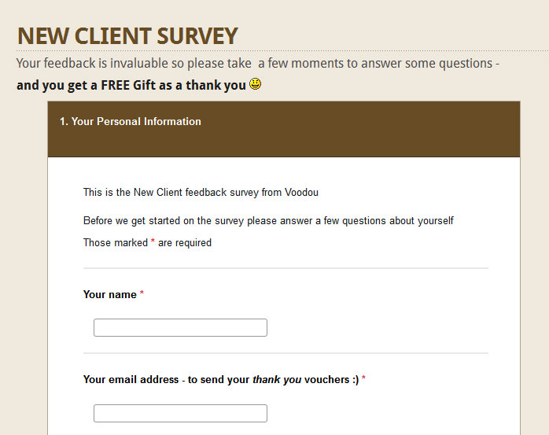

Links - Review page www.voodou.co.uk/leave-a-review/
New Client Survey www.voodou.co.uk/new-clientsurvey/

3. Three examples of how your use of new technology has improved your business, e.g. revenue growth, increased press coverage, staff recruitment, etc

- Late Deals

Every Salon has empty appointments at some time -whether it’s for a wet Monday morning or a last minute cancellation for one of our key staff. So we created Last Minute Voodou, our new website booking system, launched Mach 2012.

It allows us –
- login to the website and create Salon Deals
- edit Deals
- display Deals on our website and Facebook Page
- allow clients to Claim a Deal
- see who has claimed any Deal

The system allows us to compete with Coupon sites, fill our appointment book and attract new clients. And unlike Coupons we do not share the income, and so generate a lot more salon income and profit.

There are 2 key stages in our Deals system –

Late Deals administration
This is the back-end system that allows us to login and create and edit our Deals. We can quickly and easily add appointment slots we want to fill.
The administration system automatically emails both the Salon and the client when a Deal is “claimed” and we can restrict the number available, the dates they display and any Terms.
Late Deals for clients
The 2nd part of the system is the Client page where deals are displayed and claimed.
Deals that are not yet “live” are hidden and each claim reduces the number available.
Late Deals for clients can also be displayed/claimed in a Tab on our Salon’s Facebook page
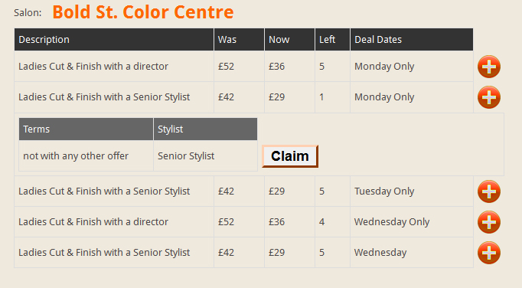
An example showing 5 deals with the + button on deal 2 selected to allow a claim to be made.
How it has generated income
- In its 1st full month of operation (April 2012) we took just under £3,000 of Last Minute Bookings through the system.
- Clients cannot choose a particular stylist for their visit and this has meant we have not had many existing clients booking via Last Minute.
- Analysis of the Last Minute bookings show over 85% are new clients who have never visited Voodou before.
- Average discount given for Last Minute bookings was 30%
Last Minute Voodou has been a great success in its 1st month and so we plan to use this system as permanent feature of our pricing structure to ensure
we no longer have quiet days in our salons

- Downloadable vouchers and email responses

Virtually every promotion we run on our website requires the client to leave their name an email. This has helped us create a database of over 35,000 clients who we can email regularly with latest news, product launches and Newsletters.

We use an online email management system that captures the data but also allows automatic follow-ups some days and weeks later.
Example 1 - Student 1st visit Discount
During the Freshers Fairs in 2011 when thousands of new students arrive in Liverpool for the 1st time we ran a website offer. The offer was promoted on our website with banners adverts, featured every day on our facebook page and supported by facebook adverts for our city.
1,475 Student Vouchers were downloaded from our website in just the 2 months we ran the promotion (Oct & Nov 2011). We sent reminders after 2 and 4 weeks and a final email 10 days before the promotion closed.

Over 65% of the vouchers were used in-salon with an average bill value of £31 and all staff were incentivised to up-sell colour and retail products.
Total income over the 2 months of the promotion was over £30,000

Example 2 – Voodou Virgins
For the start of 2012 we ran a New Client promotion called Virgin Vouchers that again supported by banner adverts on our website, facebook posts every day and facebook adverts.

From January to March 764 vouchers were downloaded, over 70% used in salon and with an average bill of £39. Total income £21,500.

The success of this 3 month campaign encouraged us to extend the closing date to the end of May and so far 1,064 vouchers have been taken, 755 used with a total income of over £30,000.
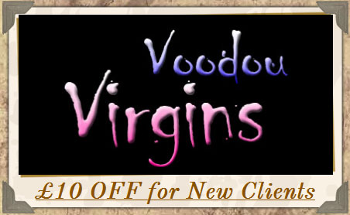

The banner advert for our website promotion Voodou Virgins.
This is one of a set of rotating adverts on our web pages we can change quickly and easily.

- Online Adverts- facebook and Google
Over past few years we have run regular online advertising campaign to support our website and facebook page. We have used facebook adverts and sponsored stories, and Google Pay Click.
Each has its own strengths, so we choose an advertising medium most suited to the campaign.
Advertising Campaigns have been used for many promotions including –
Facebook adverts & sponsored stories
Building our fanbase with “like our page” adverts with short-term facebook offers
Student discounts during Freshers Fairs
New Client Offers – “Voodou Virgin Vouchers”
“Face of Liverpool” – our yearly competition to choose a Voodou model
Win a set of ghd – one of our many online competitions

Google Pay Per Click -
Brazilian Blow Dry
Trainee Hairdressers required
Hair Extensions
Colour Correction

Facebook adverts and sponsored stories are great for broad-based campaigns where you only want to target by age, gender and location and we typically pay between 40p and 60p per “click”. They have helped boost our fans numbers and raise brand awareness.

Google Pay Per Click are more targeted as we can choose to display an advert only to people in our area who have searched for specific phrases. E.g. Our Brazilian Blow Dry campaign targeted 30 phrases as shown in this snapshot example -

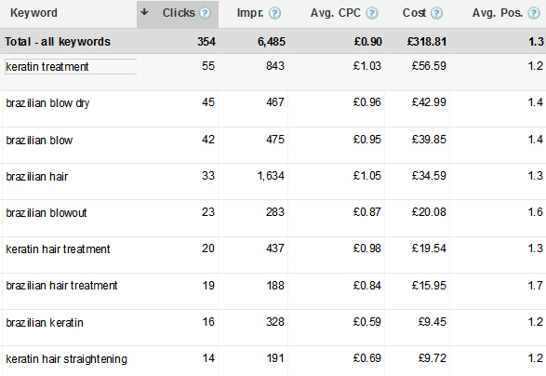

For this campaign we spent £318 over a 7 month period and it produced 354 Clicks at an average cost of £0.89 each.
Google PPC is great to give you an immediate top 3 rank for high-value keywords and phrases where the product or service can be early defined in keyphrases and words. We have used this advertising tool many times over the years, but as our websites search engine rank has vastly improved over time the need for Google PPC has changed to new services and products we launch.
Great Search Engine Optimisation eventually removes the need for Google PPC and your “organic rank results” deliver the same results. But it takes time and lots of patience to get a high rank for 30 phrases.
For the Brazilian Blow Dry we now have 9 phrases at rank 1 and 16 in the top 5.
We have repeated this process many times over the years, a Google PPC campaign for high value services and products followed by intensive SEO on our website phrases to give us the same result naturally.
Some of the Products and services we have used Google PCC then SEO
Hair Extensions
Ghd
Hair Colour
Colour Correction

Online advertising is great for quick, short-term boosts for specific campaign or services
But we always follow that with extensive SEO to give the same results
but at no cost

